**Scenario 1:**

**Code**

-- Drop if exists

BEGIN

EXECUTE IMMEDIATE 'DROP TABLE savings_accounts';

EXCEPTION

WHEN OTHERS THEN NULL;

END;

/

-- Create savings_accounts table

CREATE TABLE savings_accounts (

account_id NUMBER PRIMARY KEY,

customer_id NUMBER,

balance NUMBER(10, 2)

);

INSERT INTO savings_accounts VALUES (101, 1, 5000);

INSERT INTO savings_accounts VALUES (102, 2, 10000);

INSERT INTO savings_accounts VALUES (103, 3, 8000);

COMMIT;

CREATE OR REPLACE PROCEDURE ProcessMonthlyInterest AS

BEGIN

FOR rec IN (SELECT account_id, balance FROM savings_accounts) LOOP

UPDATE savings_accounts

SET balance = balance + (balance * 0.01)

WHERE account_id = rec.account_id;

END LOOP;

END;

/

EXEC ProcessMonthlyInterest;

SELECT * FROM savings_accounts;

**output**

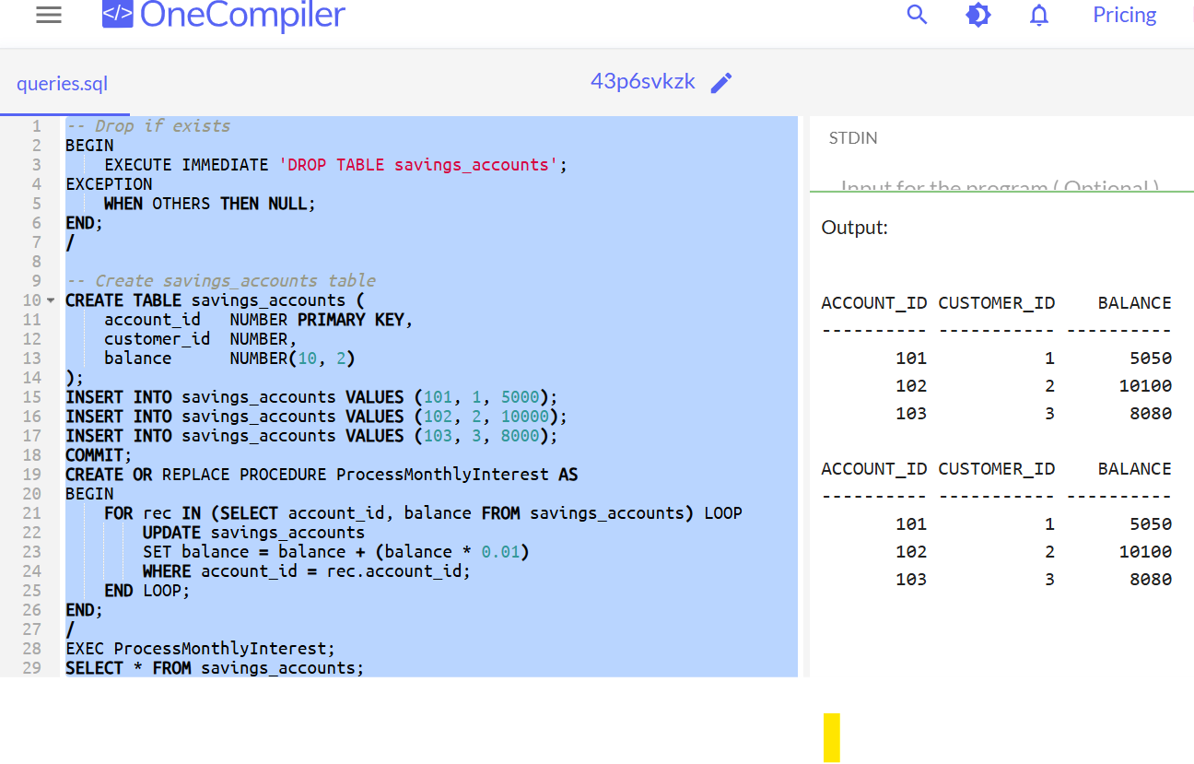

**Scenario 2:**

**Code**

-- Enable DBMS Output

SET SERVEROUTPUT ON;

-- Drop table if exists

BEGIN

EXECUTE IMMEDIATE 'DROP TABLE employees';

EXCEPTION

WHEN OTHERS THEN NULL;

END;

/

-- Create employees table

CREATE TABLE employees (

emp_id NUMBER PRIMARY KEY,

name VARCHAR2(100),

department_id NUMBER,

salary NUMBER(10, 2)

);

-- Insert sample data

INSERT INTO employees VALUES (1, 'Alice', 10, 50000);

INSERT INTO employees VALUES (2, 'Bob', 10, 55000);

INSERT INTO employees VALUES (3, 'Charlie', 20, 60000);

COMMIT;

-- Create stored procedure to update bonus

CREATE OR REPLACE PROCEDURE UpdateEmployeeBonus (

dept_id IN NUMBER,

bonus_percent IN NUMBER

) AS

BEGIN

UPDATE employees

SET salary = salary + (salary * bonus_percent / 100)

WHERE department_id = dept_id;

DBMS_OUTPUT.PUT_LINE('Bonus of ' || bonus_percent || '% applied to department ' || dept_id);

END;

/

-- Execute the procedure

EXEC UpdateEmployeeBonus(10, 10); -- Apply 10% bonus to department 10

-- View updated salaries

SELECT * FROM employees;

**Output**

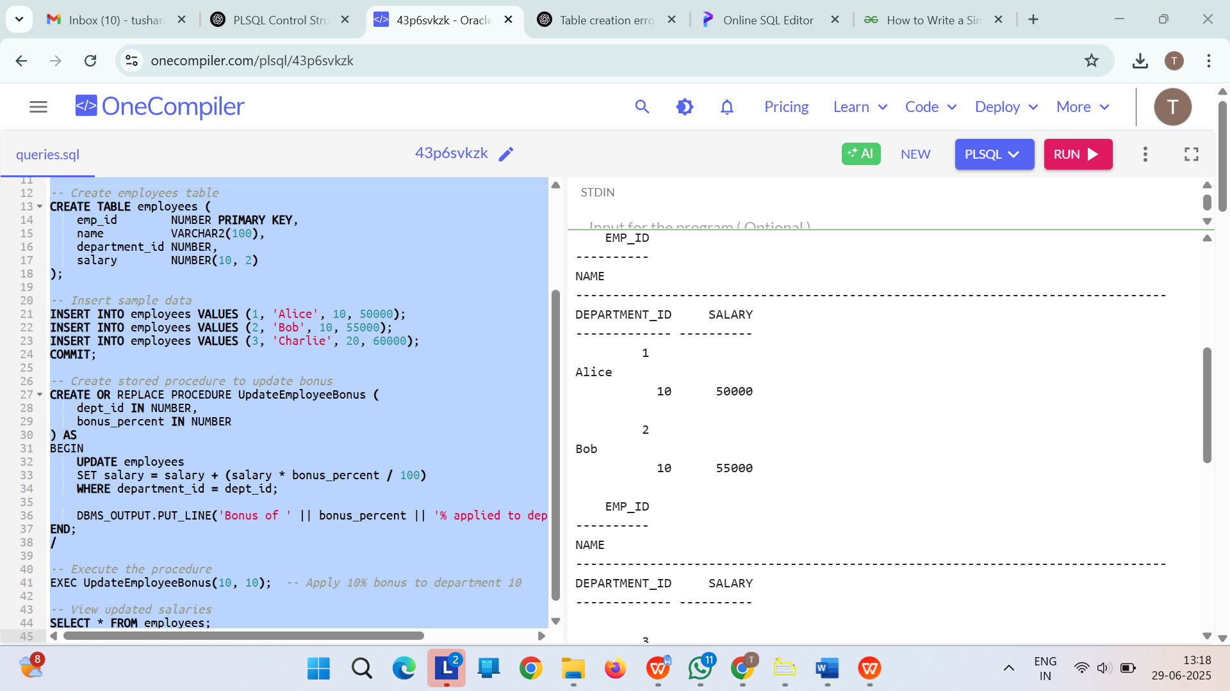

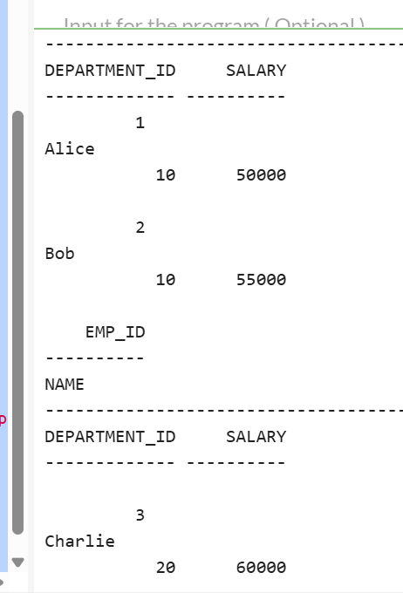

**Scenario 3:**

**Code**

-- Enable DBMS Output

SET SERVEROUTPUT ON;

-- Drop table if exists

BEGIN

EXECUTE IMMEDIATE 'DROP TABLE bank_accounts';

EXCEPTION

WHEN OTHERS THEN NULL;

END;

/

-- Create bank_accounts table

CREATE TABLE bank_accounts (

account_id NUMBER PRIMARY KEY,

customer_id NUMBER,

balance NUMBER(10, 2)

);

-- Insert sample data

INSERT INTO bank_accounts VALUES (201, 1, 10000);

INSERT INTO bank_accounts VALUES (202, 2, 5000);

COMMIT;

-- Create stored procedure for fund transfer

CREATE OR REPLACE PROCEDURE TransferFunds (

from_account IN NUMBER,

to_account IN NUMBER,

amount IN NUMBER

) AS

insufficient_balance EXCEPTION;

curr_balance NUMBER;

BEGIN

-- Get current balance of sender

SELECT balance INTO curr_balance

FROM bank_accounts

WHERE account_id = from_account;

-- Check for sufficient balance

IF curr_balance < amount THEN

RAISE insufficient_balance;

END IF;

-- Deduct from sender and add to receiver

UPDATE bank_accounts

SET balance = balance - amount

WHERE account_id = from_account;

UPDATE bank_accounts

SET balance = balance + amount

WHERE account_id = to_account;

DBMS_OUTPUT.PUT_LINE('Transfer of ' || amount ||

' from Account ' || from_account ||

' to Account ' || to_account || ' successful.');

EXCEPTION

WHEN insufficient_balance THEN

DBMS_OUTPUT.PUT_LINE('Transfer failed: Insufficient balance.');

WHEN NO_DATA_FOUND THEN

DBMS_OUTPUT.PUT_LINE('Transfer failed: One or both accounts not found.');

WHEN OTHERS THEN

DBMS_OUTPUT.PUT_LINE('Unexpected error: ' || SQLERRM);

END;

/

-- Execute procedure (successful)

EXEC TransferFunds(201, 202, 2000);

-- Try with insufficient balance

EXEC TransferFunds(202, 201, 10000);

-- View final account balances

SELECT * FROM bank_accounts;

**Output**

